AI ASSISTED CODING
ASSIGNMENT - 13.1&13.5
NAME: P.SAI SHANKAR
HL-NO: 2303A52500 BATCH: 50
Lab 13.1 and 13.5:
Task-1:
def calculate_rectangle_metrics(length, width):
"""
Calculate and print the area and perimeter of a rectangle.
Parameters:
length (int or float): The length of the rectangle.
width (int or float): The width of the rectangle.

Returns:
None
"""
area = length * width
perimeter = 2 * (length + width)
print(f"Area of Rectangle: {area}")
print(f"Perimeter of Rectangle: {perimeter}")
print("-" * 30)
def main():
"""
Main function to call rectangle calculations
for multiple rectangle dimensions.
"""
rectangles = [
(5, 10),
(7, 12),
(10, 15)
]
for length, width in rectangles:
calculate_rectangle_metrics(length, width)
if __name__ == "__main__":
main()

Output:
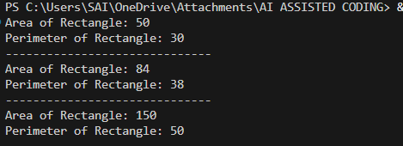

Task-2:
def calculate_total(price: float, tax_rate: float = 0.18) -> float:
"""
Calculates the total price including tax.

Args:
price (float): The base price of the item.
tax_rate (float): The tax rate to apply. Defaults to 0.18.
Returns:
float: The total price after adding tax.
"""
tax = price * tax_rate
return price + tax
def main():
# List of prices to process
prices = [250, 500]
for price in prices:
total = calculate_total(price)
print(f"Total Price: {total}")
if __name__ == "__main__":
main()

Output:
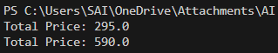

Task-3:
class GradeCalculator:
"""
A class used to calculate student grades based on marks.
"""
def calculate_grade(self, marks):
"""
Calculates the grade for a given mark.

Parameters:
marks (int or float): The student's marks (0-100).
Returns:
str: The corresponding grade description.
"""
if 90 <= marks <= 100:
return "Grade A"
elif marks >= 80:
return "Grade B"
elif marks >= 70:
return "Grade C"
elif marks >= 40:
return "Grade D"
else:
return "Fail"
# Create an object of GradeCalculator
calculator = GradeCalculator()
# Test cases
test_marks = [85, 72, 95, 45, 30]
for marks in test_marks:
grade = calculator.calculate_grade(marks)
print(f"Marks: {marks} -> {grade}")

Output:
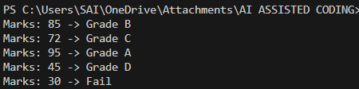

Task-4:
def get_input():
return int(input("Enter number: "))

def calculate_square(num):
return num * num
def display_result(square):
print("Square:", square)
def main():
num = get_input()
square = calculate_square(num)
display_result(square)
if __name__ == "__main__":
main()

Output:
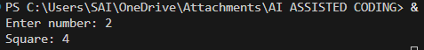

Task-5:
class EmployeeSalaryCalculator:
def __init__(self, salary, tax_rate=0.2):
self.salary = salary
self.tax_rate = tax_rate

def calculate_tax(self):
return self.salary * self.tax_rate
def calculate_net_salary(self):
return self.salary - self.calculate_tax()
def display_net_salary(self):
print(self.calculate_net_salary())
if __name__ == "__main__":
calculator = EmployeeSalaryCalculator(50000)
calculator.display_net_salary()

Output:

Task-6:
# Task 6 (Optimizing Search Logic)
# Refactored search logic using a set for O(1) average time complexity

# Legacy Code used a list O(n) search time.
# A set is chosen because lookups are O(1) on average.
users = {"admin", "guest", "editor", "viewer"}
name = input("Enter username: ")
# Set lookup is efficient and scales well with large datasets
if name in users:
print("Access Granted")
else:
print("Access Denied")

Output:
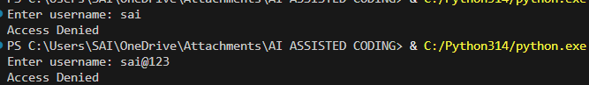

Task-7:
"""
Library Management System Module (OOP Version)

This module provides a Library class to manage books
using object-oriented programming principles.
"""
class Library:
"""
A class to represent a library management system.
"""
def __init__(self):
"""
Initialize the library with an empty database.
"""
self.library_db = {}
def add_book(self, title, author, isbn):
"""
Add a new book to the library.
Parameters:
title (str): Title of the book.
author (str): Author of the book.
isbn (str): Unique ISBN number.
Returns:
str: Success or error message.
"""
if isbn not in self.library_db:
self.library_db[isbn] = {
"title": title,
"author": author
}
return "Book added successfully."
return "Book already exists."
def remove_book(self, isbn):
"""
Remove a book from the library.
Parameters:
isbn (str): ISBN of the book to remove.
Returns:
str: Success or error message.
"""
if isbn in self.library_db:
del self.library_db[isbn]
return "Book removed successfully."
return "Book not found."
def search_book(self, isbn):
"""
Search for a book using ISBN.
Parameters:
isbn (str): ISBN of the book to search.
Returns:
dict or str: Book details if found, otherwise error message.
"""
if isbn in self.library_db:
return self.library_db[isbn]
return "Book not found."

Output:
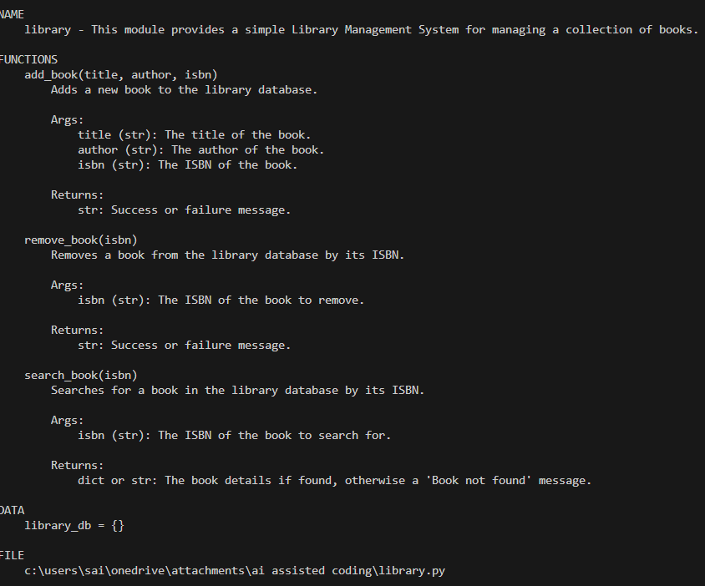
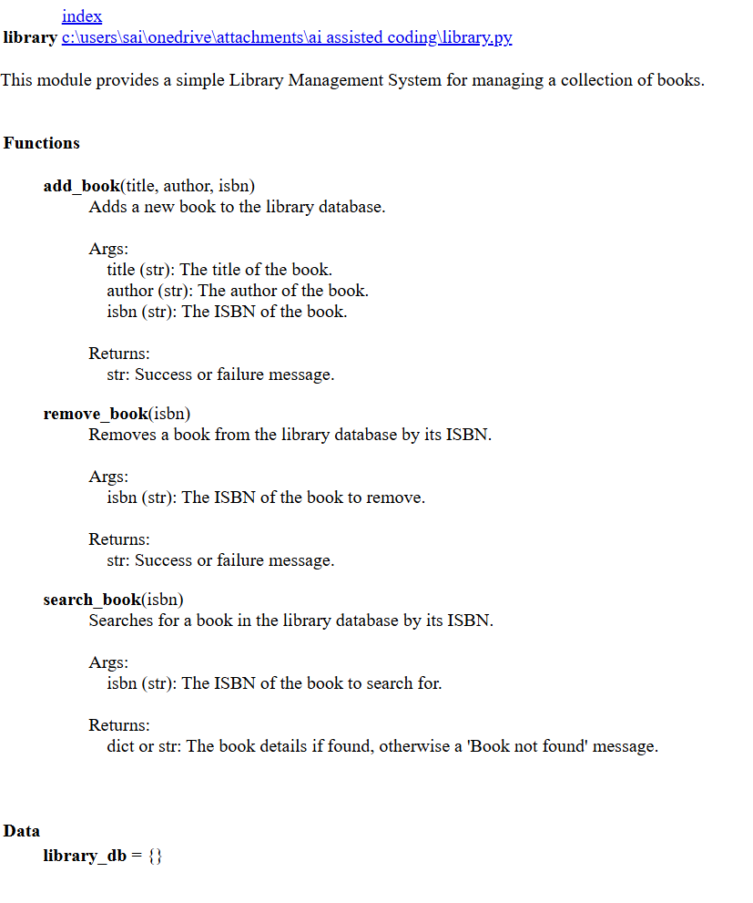

Task-8:
def generate_fibonacci(n):
"""
Generate Fibonacci series up to n terms.

Parameters:
n (int): Number of Fibonacci terms to generate.
Returns:
list: A list containing Fibonacci sequence up to n terms.
Raises:
ValueError: If n is negative.
"""
if n < 0:
raise ValueError("Number of terms cannot be negative.")
if n == 0:
return []
if n == 1:
return [0]
fibonacci_series = [0, 1]
for _ in range(2, n):
fibonacci_series.append(
fibonacci_series[-1] + fibonacci_series[-2]
)
return fibonacci_series
# ---------------- TEST CASES ---------------- #
if __name__ == "__main__":
print("Test Case 1 (n=5):", generate_fibonacci(5))
print("Test Case 2 (n=1):", generate_fibonacci(1))
print("Test Case 3 (n=0):", generate_fibonacci(0))

Output:
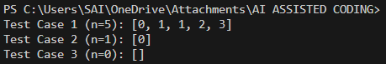

Task-9:
import math

def is_prime(n):
"""
Check whether a number is prime.
Parameters:
n (int): Number to check.
Returns:
bool: True if n is prime, otherwise False.
"""
if n <= 1:
return False
if n == 2:
return True
if n % 2 == 0:
return False
# Check divisibility only up to √n
for i in range(3, int(math.sqrt(n)) + 1, 2):
if n % i == 0:
return False
return True
def is_twin_prime(p1, p2):
"""
Check whether two numbers form a twin prime pair.
Parameters:
p1 (int): First number.
p2 (int): Second number.
Returns:
bool: True if both are prime and differ by 2.
"""
return is_prime(p1) and is_prime(p2) and abs(p1 - p2) == 2
def generate_twin_primes(start, end):
"""
Generate all twin prime pairs within a given range.
Parameters:
start (int): Starting range.
end (int): Ending range.
Returns:
list: List of twin prime tuples.
"""
twin_primes = []
for num in range(start, end - 1):
if is_twin_prime(num, num + 2):
twin_primes.append((num, num + 2))
return twin_primes
# ---------------- TEST CASES ---------------- #
if __name__ == "__main__":
print("Check (11,13):", is_twin_prime(11, 13))
print("Check (17,19):", is_twin_prime(17, 19))
print("Check (10,12):", is_twin_prime(10, 12))
print("\nTwin primes between 1 and 50:")
print(generate_twin_primes(1, 50))

Output:
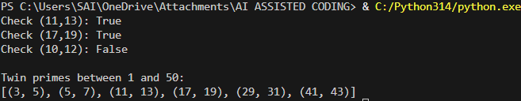

Task-10:
"""
Chinese Zodiac Module
Provides functionality to determine the Chinese Zodiac sign
based on a given year.
"""

def get_zodiac(year):
"""
Determine the Chinese Zodiac sign for a given year.
Parameters:
year (int): The year for which the zodiac sign is required.
Returns:
str: The corresponding Chinese Zodiac sign.
"""
zodiac_cycle = [
"Monkey", # 0
"Rooster", # 1
"Dog", # 2
"Pig", # 3
"Rat", # 4
"Ox", # 5
"Tiger", # 6
"Rabbit", # 7
"Dragon", # 8
"Snake", # 9
"Horse", # 10
"Goat" # 11
]
return zodiac_cycle[year % 12]
def main():
"""
Handle user input and display the zodiac result.
"""
try:
year = int(input("Enter a year: "))
zodiac = get_zodiac(year)
print(f"Chinese Zodiac Sign: {zodiac}")
except ValueError:
print("Invalid input. Please enter a valid year.")
if __name__ == "__main__":
main()

Output:
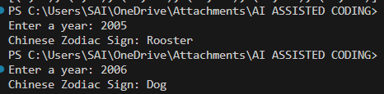

Task-11:
"""
Harshad (Niven) Number Checker Module
Provides functionality to check whether a number is a Harshad number.
"""

def is_harshad(number):
"""
Check whether a number is a Harshad (Niven) number.
A Harshad number is divisible by the sum of its digits.
Parameters:
number (int): The integer to evaluate.
Returns:
bool: True if the number is a Harshad number, False otherwise.
Notes:
- Negative numbers are evaluated using their absolute value.
- 0 is not considered a Harshad number.
"""
# Handle negative numbers
number = abs(number)
# Edge case: 0
if number == 0:
return False
digit_sum = 0
temp = number
# Calculate sum of digits
while temp > 0:
digit_sum += temp % 10
temp //= 10
if digit_sum == 0:
return False
return number % digit_sum == 0
def main():
"""
Handle user interaction and display result.
"""
try:
user_input = int(input("Enter a number: "))
result = is_harshad(user_input)
print(result)
except ValueError:
print("Invalid input. Please enter an integer.")
if __name__ == "__main__":
main()

Output:
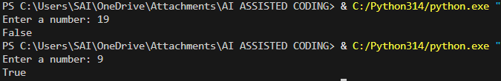

Task-12:
"""
Factorial Trailing Zeros Module
Provides functionality to count trailing zeros in n!
using an optimized mathematical approach.
"""

def count_trailing_zeros(n):
"""
Calculate the number of trailing zeros in n! (factorial of n).
The function uses an optimized method by counting
multiples of 5 instead of computing the full factorial.
Parameters:
n (int): A non-negative integer.
Returns:
int: Number of trailing zeros in n!.
Raises:
ValueError: If n is negative.
"""
if n < 0:
raise ValueError("Input must be a non-negative integer.")
count = 0
divisor = 5
while n >= divisor:
count += n // divisor
divisor *= 5
return count
def main():
"""
Handle user input and display the number of trailing zeros.
"""
try:
number = int(input("Enter a number: "))
zeros = count_trailing_zeros(number)
print(f"Trailing zeros: {zeros}")
except ValueError as e:
print(f"Error: {e}")
if __name__ == "__main__":
main()

Output:
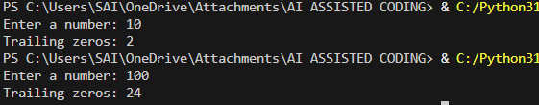

Task-13:
"""
Collatz Sequence Generator with Pytest Test Cases
--------------------------------------------------
This file contains:
1. generate_collatz() function
2. Test cases using pytest
"""

def generate_collatz(n):
"""
Generate the Collatz sequence starting from n until reaching 1.
Rules:
- If n is even → n = n // 2
- If n is odd → n = 3n + 1
- Repeat until n becomes 1
Parameters:
n (int): A positive integer
Returns:
list: Full Collatz sequence ending in 1
Raises:
ValueError: If n <= 0
TypeError: If input is not an integer
"""
if not isinstance(n, int):
raise TypeError("Input must be an integer.")
if n <= 0:
raise ValueError("Input must be a positive integer.")
sequence = [n]
while n != 1:
if n % 2 == 0:
n = n // 2
else:
n = 3 * n + 1
sequence.append(n)
return sequence
# =========================
# Pytest Test Cases
# =========================
import pytest
# ✅ Normal Case
def test_normal_case():
assert generate_collatz(6) == [6, 3, 10, 5, 16, 8, 4, 2, 1]
# ✅ Edge Case
def test_edge_case():
assert generate_collatz(1) == [1]
# ✅ Negative Case
def test_negative_case():
with pytest.raises(ValueError):
generate_collatz(-5)
# ✅ Large Case (27 produces a long sequence)
def test_large_case():
result = generate_collatz(27)
assert result[0] == 27
assert result[-1] == 1
assert len(result) > 100

Output:
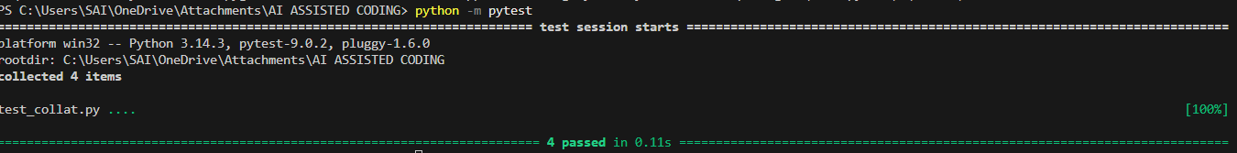

Task-14:
"""
Lucas Sequence Generator with Pytest Test Cases
------------------------------------------------
Lucas sequence:
Starts with 2, 1
Fn = Fn-1 + Fn-2
"""

def generate_lucas(n):
"""
Generate Lucas sequence up to n terms.
Parameters:
n (int): Number of terms (must be positive)
Returns:
list: Lucas sequence of length n
Raises:
ValueError: If n <= 0
TypeError: If n is not an integer
"""
if not isinstance(n, int):
raise TypeError("Input must be an integer.")
if n <= 0:
raise ValueError("Number of terms must be positive.")
if n == 1:
return [2]
sequence = [2, 1]
for _ in range(2, n):
sequence.append(sequence[-1] + sequence[-2])
return sequence
# ======================
# PYTEST TEST CASES
# ======================
import pytest
# ✅ Normal Case
def test_normal():
assert generate_lucas(5) == [2, 1, 3, 4, 7]
# ✅ Edge Case
def test_edge():
assert generate_lucas(1) == [2]
# ✅ Negative Case
def test_negative():
with pytest.raises(ValueError):
generate_lucas(-5)
# ✅ Large Case
def test_large():
result = generate_lucas(10)
assert result[-1] == 76
assert len(result) == 10

Output:
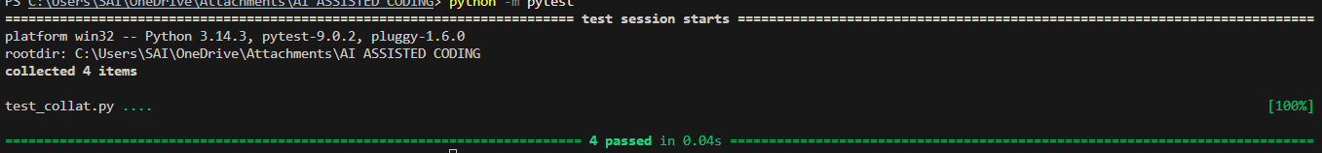

Task-15:
"""
Vowel & Consonant Counter with Pytest Test Cases
------------------------------------------------
Counts vowels and consonants in a given string.
"""

def count_vowels_consonants(text):
"""
Count vowels and consonants in a string.
Parameters:
text (str): Input string
Returns:
tuple: (vowel_count, consonant_count)
Notes:
- Only alphabetic characters are counted.
- Case-insensitive.
- Non-alphabet characters are ignored.
"""
if not isinstance(text, str):
raise TypeError("Input must be a string.")
vowels = "aeiouAEIOU"
vowel_count = 0
consonant_count = 0
for char in text:
if char.isalpha():
if char in vowels:
vowel_count += 1
else:
consonant_count += 1
return vowel_count, consonant_count
# ======================
# PYTEST TEST CASES
# ======================
import pytest
# ✅ Normal Case
def test_normal():
assert count_vowels_consonants("hello") == (2, 3)
# ✅ Edge Case (Empty String)
def test_edge_empty():
assert count_vowels_consonants("") == (0, 0)
# ✅ Only Vowels
def test_only_vowels():
assert count_vowels_consonants("aeiou") == (5, 0)
# ✅ Large Text
def test_large_text():
text = "This is a long text used for testing vowel and consonant counting logic."
vowels, consonants = count_vowels_consonants(text)
assert vowels > 0
assert consonants > 0
# ✅ Non-string input
def test_invalid_input():
with pytest.raises(TypeError):
count_vowels_consonants(123)

Output: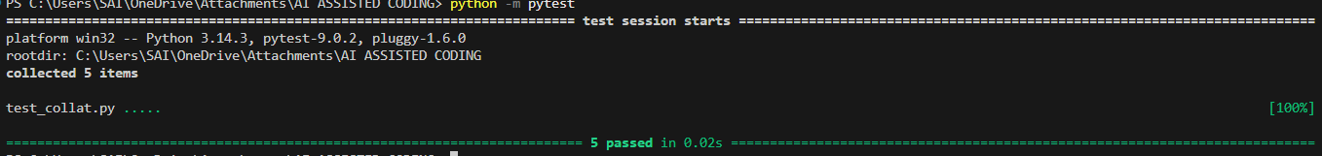

Task-16:
def calculate_interest(amount, rate):
"""
Calculate simple interest based on amount and rate.

Parameters:
amount (float): Principal amount.
rate (float): Interest rate (e.g., 0.1 for 10%).
Returns:
float: Calculated interest.
"""
return amount * rate
def main():
"""
Handle execution and configuration.
"""
rate = 0.1
result = calculate_interest(1000, rate)
print(result)
if __name__ == "__main__":
main()

Output:

Task-17:
def get_grade(score):
"""
Determine grade category based on score.

Parameters:
score (int or float): Student score.
Returns:
str: Grade category.
"""
if score >= 90:
return "Excellent"
if score >= 75:
return "Very Good"
if score >= 60:
return "Good"
return "Needs Improvement"
def main():
score = 78
print(get_grade(score))
if __name__ == "__main__":
main()

Output:

Task-18:
def read_and_print_file(filename):
"""
Read and print the contents of a file.

Parameters:
filename (str): Path to the file to read.
Returns:
None
"""
try:
with open(filename, "r") as file:
print(file.read())
except FileNotFoundError:
print(f"Error: File '{filename}' not found.")
except IOError as e:
print(f"Error reading file '{filename}': {e}")
def main():
"""
Call reusable file reading function.
"""
read_and_print_file("data1.txt")
read_and_print_file("data2.txt")
if __name__ == "__main__":
main()

Output:

Task-19:
def check_access(username, users):
"""
Check whether a username exists in the system.

Parameters:
username (str): Username to check.
users (set): Set of valid usernames.
Returns:
bool: True if user exists, otherwise False.
"""
return username in users
def main():
users = {"admin", "guest", "editor", "viewer"} # Set instead of list
name = input("Enter username: ")
if check_access(name, users):
print("Access Granted")
else:
print("Access Denied")
if __name__ == "__main__":
main()

Output:
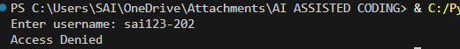

Task-20:
class EmployeeSalaryCalculator:
"""
A class to calculate tax and net salary for an employee.
"""

def __init__(self, salary, tax_rate=0.2):
"""
Initialize salary calculator.
Parameters:
salary (float): Employee's gross salary.
tax_rate (float): Tax rate (default 20%).
"""
self.salary = salary
self.tax_rate = tax_rate
def calculate_tax(self):
"""
Calculate tax amount.
Returns:
float: Tax amount.
"""
return self.salary * self.tax_rate
def calculate_net_salary(self):
"""
Calculate net salary after tax deduction.
Returns:
float: Net salary.
"""
return self.salary - self.calculate_tax()
def display_salary_details(self):
"""
Print salary breakdown.
"""
print(f"Gross Salary: {self.salary}")
print(f"Tax: {self.calculate_tax()}")
print(f"Net Salary: {self.calculate_net_salary()}")
# ---------------------
# Example Usage
# --------------------
if __name__ == "__main__":
employee = EmployeeSalaryCalculator(50000)
employee.display_salary_details()

Output:
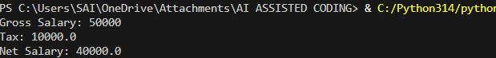

Task-21:
def sum_even_numbers(limit):
"""
Calculate sum of even numbers below a given limit
using mathematical formula.

Parameters:
limit (int): Upper bound (exclusive)
Returns:
int: Sum of even numbers
"""
n = (limit - 1) // 2 # count of even numbers
return n * (n + 1)
if __name__ == "__main__":
print(sum_even_numbers(1000000))

Output:
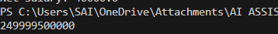

Task-22:
def add_item(data, x):
"""
Return a new list with the new item added.

Parameters:
data (list): Existing list
x (any): Item to add
Returns:
list: New list with item added
"""
return data + [x]
def main():
data = []
data = add_item(data, 10)
data = add_item(data, 20)
print(data)
if __name__ == "__main__":
main()

Output:

Task-23:
"""
Password Validation Module
Provides modular password validation functions.
"""

def is_long_enough(password):
"""Check if password length is at least 8 characters."""
return len(password) >= 8
def contains_digit(password):
"""Check if password contains at least one digit."""
return any(c.isdigit() for c in password)
def contains_uppercase(password):
"""Check if password contains at least one uppercase letter."""
return any(c.isupper() for c in password)
def validate_password(password):
"""
Validate password using multiple rules.
Returns:
tuple: (is_valid: bool, message: str)
"""
if not is_long_enough(password):
return False, "Password too short"
if not contains_digit(password):
return False, "Must contain digit"
if not contains_uppercase(password):
return False, "Must contain uppercase"
return True, "Valid Password"
def main():
password = input("Enter password: ")
valid, message = validate_password(password)
print(message)
if __name__ == "__main__":
main()

Output:
